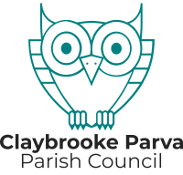

**SPINNEY VIEW FARM UPDATE**

The Parish Council have been made aware of some residents' concerns about activities at Spinney View Farm, Claybrooke Parva.

These concerns have been reported to Harborough District Council (HDC) and the Environment Agency (EA). Any environmental enforcement action rests with the EA who are investigating.

8.11.24