**CLAYBROOKE PARVA PARISH COUNCIL**

**Minutes of the Meeting of Claybrooke Parish Council held on 20th March 2019 at Claybrooke Parva School Hall at 7.30pm**

**Present:**

Cllr Ian Robertson, Cllr Gillian M acart hur , Cllr Carole Allen, Cllr Graham Hart and Cllr Neil Blackhall.

**In attendance:**

District and County Cllr Rosita Page , 5 members of the public and Katherine Clarke acting as Parish Clerk .

1. **Election of Chairman**

It was resolved that Cllr Robertson would Chair the meet ing .

1. **Welcome**

Cllr Rob ert son welcomed everyone to the meeting and introduced Katherine Clark e to those present, a dvisin g that she would be acting as Parish Clerk for the meeting.

1. **Apologies for Absence**

No apologies for absence received.

1. **Declarations of Acceptance of Office Forms to be received for two co-opted Councillors**

Cllr Hart and Cllr Blackhall accepted and signed their Declarations of Acceptance of Office which were then countersigned by the Clerk as Proper Officer of the Council.

1. **Declarations of Members' Interests**

No declarations of interest received .

1. **Acceptance of minutes of meeting held on 9th January 2019**

The minutes of the meeting held on 9th January 2019, prepared by District Cllr Rosita Page were approved and signed as an acc urat e record .

1. **Public Participation (15-minute duration)**

* A parishioner raised concerns regarding the disgusting state of the roads with all the building work going on at Magna Park. District Cllr Page advised the traffic management plan was approved as part of the planning application; complaints should be sent directly to Volker Fitzpatrick. Leicestershire County Council will monitor the works and once complete they will advise Volker Fitzpatrick to reinstate damaged verges etc. Cllr Hart advised that *he* didn't recall Mere Lane being

closed for so long in the traffic management plan. District Cllr Page advised the Parish Council to check this with Leicestershire County Council, if they are not adhering to the plan inform Cllr Page.

* It was noted that the Tree Warden has re si gned. It was questioned whether the Parish Council knows which trees are protected. A parishioner has been approached by District Cllr Page to take on the role. District Cllr Page suggested that the Parish Council set a brief of what the Tree Warden would be required to do, once the role is filled the Warden can investigate which trees are protected with a Tree Protection Order. Following brief Council discussion, it was considered there was little requirement for a Tree Warden due to the size of Claybrooke Parva also that significant portion of the Parish already being within a Conservation area. The Council will review and conclude a decision at a future meeting.

1. **To receive oral report from District and County Councillor Rosita Page**

District Cllr Page reminded the meeting of the upcoming Elections in May 2019 and of key dates for submitting Nominations.

1. **Finance**

/

1. Cllr Macarthur presented the bank reconciliation as at 28th February 2019 which was signed by the Chair and the Clerk. Payments raised during the period: Rich & Carr Solicitors £286.00.
2. The following payments were approved:

|  |  |  |
| --- | --- | --- |
| E-on Electricity | Period to 31.12.18 | £13.38 |
| Claybrooke Joint Burial Board | Precept contribution to 31.03.20 | £249 .00 |

It was noted that a final grass cut was undertaken in March and an invoice of £81.00 is expected. It was agreed that a cheque can be raised to settle this in advance of the next meeting.

1. It was resolved that the authorised signatories in the current mandate for the NatWest bank account be amended to add Cllr Hart and Cllr Blackhall as authorised signatories with immediate effect.
2. It was resolved not to amend the current address for all banking correspondence until a new Clerk is appointed. The situation will be reviewed at the next meeting.
3. It was resolved not to consider on-line banking until a new Clerks is appointed. This situation will be reviewed at the next meeting.
4. Cllr Macarthur advised that Enrol Pay have offered to prepare and submit the final nil RTI submissions for March 2019 and submit the payroll year-end free of charge. It was resolved to approve thi s.

The Chair thanked Cllr Macarthur for the work undertaken on the finances.

1. **Parish Clerk Vacancy**

a) District Cllr Page has the details of someone who may be prepared to act as a joint Clerk for Claybrooke Parva and Claybrooke M agna. Cllr Roberts advised that the vacancy for the position of Clerk would be advertised.

B) Approval was given to re-run the advertisement in The New Swift Flash.

c) It was agreed to contact LRALC and see if the vacancy can be placed on their site and included in their Friday round robin email circulation.

1. **Planning applications received since the last Parish Council meeting**
2. 18/02136/FUL I Erection of 12 dog kennels and variation of hours of opening to allow overnight boarding of dogs (amended description) I Watling House , Watling Street, Claybrooke Parva - a response has been submitted as there are no objections to the applicati on.
3. Harborough District Council Local Plan - a response has been submitted on behalf of the Parish Council.
4. **Correspondence**

The only correspondence to note is interest in the Parish Clerk vacancy .

1. **Community Activity/ Enhancement**
2. Litter Pick

It was suggested that the litter pick takes place on Saturday 13th April 2019 at 10am . Cllr Robertson will contact John Kemp at Harborough District Council to arrange. Cllr Blackwell will contact Brian Fowler with the details to be circulated in the newsl etter .

1. Village Green/ Green Lane

An oral report was provided by a parishioner. Actions - Green Lane:

* + Include Green Lane in the village pick.
  + Letter to be sent to the Joint Burial Board regarding fencing.
  + Parish Council to go and view the site.
  + Cllr Hart to start looking at ownership and provide schematic.

Actions - Village Green:

* + A plan needs to be in place for what people want to happen on the Green.
  + Local colleges have been contacted to see if they are interested in being involved with the mai nt enance , but no interest has been received to date. Cllr Hart has a possible contact to explore and Cllr Allen will contact a wild gardening company she is aware of.
  + A list of 'do's and don'ts' for the land needs to be compiled .

3

L ..

* + Cllr Hart proposed and Cllr Robertson· econded· the formation of a sub-committee, all agreed. The Friends of the Green group will be kept advised of developments.

**14AOB**

District Cllr Page was asked by the Chairman Cllr Roberts if she had already recommended or intended to recommend in the next 12 months to Harborough District Council that Claybrooke Parva and Claybrooke Magna Parish Councils are merged? District Cllr Page confirmed that it was her intention to recommend the amalgamation /merger of Claybrooke Parva & Magna Parish Councils.

Cllr Hart asked District Cllr Page under what authority she considered existed for a merger? District Cllr Page advised she had received three emails from Parishioners raising concern at the disparity in precept charge between Parva & Magna and asking why the Parishes could not be merged. Cllr Hart advised District Cllr Page that such reasoning did not conform with the legal processes existing under which a District Council may consider the merger of Parish Councils or Parishes.

District Cllr Page advised that any merger would involve a public referendum . Cllr Hart advised that concern about precept level is not a legal reason for Harborough District Council to trigger a referendum. Cllr Hart stated that if a merge was recommended by District Cllr Page and Harborough District Council then moved to trigger a referendum based on precept concerns the Parish Council would challenge the legal validity of Harborough District Council actions. District Cllr Page advised Cllr Hart that this is as it should be.

Cllr Hart advised Distr ict Cllr Page that she did not have the support of Claybrooke Parva Parish Council.

**15 Legal action against Claybrooke Parva Parish Council**

It was resolved that in accordance with the Public Bodies (Admission to Meetings) Act 1960 to exclude the public and press for agenda item 15 as the discussion concerned professi onal legal advice protected by legal and professional privilege.

Cllr Page and members of the public left the meeting at 8.55pm.

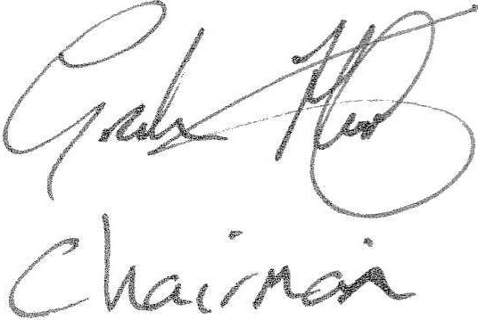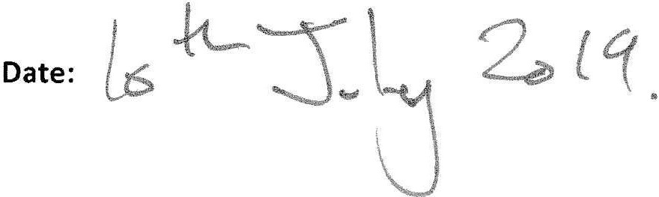The Pa ri sh Council resolved to accept the advice from the legal brief. The meeting closed at 9.10pm.

**Signed:**

4

.