Claybrooke PARVA PARISH COUNCIL

Emergency Plan

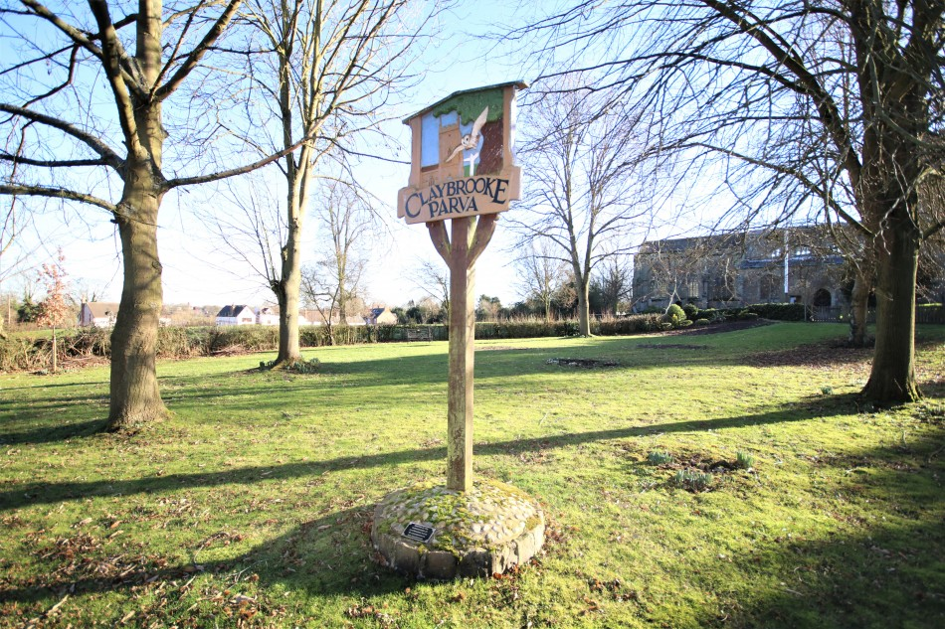

YOUR FIRST RESPONSE  
  
In the event of an emergency of any kind in   
Claybrooke Parva   
DIAL 999

YOUR FIRST ACTION

THEN TURN TO THE NEXT PAGE OF THIS PLAN

|  |  |
| --- | --- |
| Last updated: | May 2021 |
| To be reviewed : | May 2022 |
| Plan Owner: | Claybrooke Parva Parish Council |
| Plan Co-ordinator: | Parish Chairman |

**CONTENTS**

Page 2 What To Do In the Event of an Emergency and Emergency Team Contact Information

Page 3 Helping Vulnerable People/Street Warden Details/Co-ordination and Rest Centre (Village Hall) Details

Pages 4 Emergency Kit Information and useful Contact Numbers

Page 5 Emergency Resources Contact Information

Page 6 Information on Potential Risks

Page 7 Plan Distribution**WHAT TO DO IN THE EVENT OF AN EMERGENCY**

Ring 999 - The Emergency Services. They will ask you for details of what has happened, where, when and who is involved.

Give YOUR contact details to the Emergency Services so they can call you back. Ring them again if the situation changes significantly.

Contact the Claybrooke Parva Emergency Planning Team below. It is unlikely that everyone on the list below will be available when you call, so please start at the top and **keep ringing each in turn u**ntil you get a response.

|  |  |  |
| --- | --- | --- |
| **Claybrooke Parva Emergency Team Members** | | |
| **Role** | **Name** | **Contact Numbers** |
| Parish Council Chairman | Graham Hart | 07722 781142 |
| Councillor | Andrew Briggs |  |
| Councillor | Carl Fulcher | 07770 682159 |
| Councillor | Dave Coventry | 07540 929696 |
| Deputy Chairman | Neil Blackhall | 01455 202628 |
| Parish Clerk | Patricia Nunn | 07926 202967 |
| District/County Councillor | Rosita Page | 01455 209240 |

**NB: The Claybrooke Emergency Team’s role is to be a focal point locally to assist in communication, coordination and liaison, working to support the Emergency Services and, if appropriate, the HDC Resilience Partnership. The team will follow the directions of the Emergency Services at all times.**

Ways in which the team may provide support includes:

* Providing local knowledge to the Emergency Services
* Setting up links with local groups, organisations and useful individuals
* Passing on information and instructions to local people
* Providing information about people who may be particularly vulnerable such as those with disabilities or are elderly
* Making sure that buildings in the area are available for possible emergency use
* Organising local help as required, such as emergency centres, food provision and information points

This plan has information to help all the support services, but it can never be exhaustive. It must be seen as a list of people and resources that have agreed to help if needed and if they are available.

**HELPING VULNERABLE PEOPLE**

The most vulnerable people in Claybrooke Parva may need specific help and support. These may include the elderly or people with disabilities. To help identify and assist those who may need this extra support, the village has established a network of volunteers. In the event of an emergency they will help make contact with and provide information to people in need. They can be contacted as follows:

**REST CENTRE**

Claybrooke Parva School Hallwill be used as a centre for co-ordinating the response to a local emergency. It will also be used as a temporary rest centre to provide shelter and welfare, until the authorities attend.

Keyholders to this venue are:.

Mr Matthew Howard (Head Teacher)

Mobile :  07913 264705

Mr Terry Durham (School Premises Officer)

Mobile : 07896 575774

**EMERGENCY KIT INFORMATION**

|  |
| --- |
| A bag of useful equipment is located at the school, including:  Copy of this plan |
| Torch and spare batteries |
| First Aid kit (Located in School Hall) |
| Pens, pencils, writing pads |
| High-visibility jackets  Defibrillator available outside Village Hall, Claybrooke Magna |

**USEFUL CONTACT NUMBERS**

|  |  |  |
| --- | --- | --- |
| **LOCAL GOVERNMENT**  **LOCAL GOVT EMERGENCY PLANNERS** | Harborough District Council | 01858 828282 |
| Local Resilience Duty Officer | 07786 198283 |
|  |  |
| **GAS** | National Gas Emergency Service | 0800 111 999 |
|  |  |
| **ELECTRICITY** | WPD East Midlands | 105 |
| WPD mobile user | 0330 123 5009 |
|  |  |
| **FLOOD** | Environment Agency Hotline | 0345 9881188 |
|  |  |
| **MEDICAL**  **NEAREST A&E**  **NEAREST URGENT CARE CENTRE** | NHS 111 | 111 |
| George Eliot Hospital, Nuneaton | 02476 351351 |
| Hospital of St Cross, Rugby | 01788 572831 |
|  |  |
| **ROADS** | Highways Agency | 0300 123 5000 |
| County Council Highways | 0116 305 0001 |
|  |  |
| **WATER** | Severn Trent | 0800 783 4444 |
| Anglian Water -leaks | 0800 771 881 |
| Anglian – water supply/sewerage | 03457 145 145 |
|  |  |
| **SOCIAL CARE** | Adult Social Care Emergency | 0116 305 0004 |
| Child Social Care Emergency | 0116 305 0005 |
| Out of Hours Care Team | 0116 255 1606 |
|  |  |
| **LOCAL MEDIA** | Radio Leicester 104.9 FM  [radio.leicesternews@bbc.co.uk](mailto:radio.leicesternews@bbc.co.uk) | 0116 251 1049  0116 251 6688 |
| BBC East Midlands Television News [emt@bbc.co.uk](mailto:emt@bbc.co.uk) | 0115 955 0500 |
| Harborough Mail  [newsdesk@harboroughmail.co.uk](mailto:newsdesk@harboroughmail.co.uk) | 01858 436000 |

**EMERGENCY RESOURCES CONTACT INFORMATION**

These details are updated regularly. They include local people/organisations who may be able to provide some help. Circulation is restricted, but will be made available if this plan is activated.

|  |  |  |  |
| --- | --- | --- | --- |
| **Local people who can help:** | | |  |
| **Who** | **Help Available** | | **Contact Details** |
| **Local Buildings - Recovery Centre** | | | |
| School Hall | Emergency Rendezvous Point | | Main Road, Claybrooke Parva |
| **Landowners** | | | |
| Bob and Julie Jennings | Tractor, Trailer, Steel Tow Rope, Horse Box, use of field | | Bob 07768 722715  Julie 07917874887 |
| **Neighbouring Help** | | | |
| Rev Sr Liz Heaton | St Peter’s Church support network | | 01455 202935  uppersoar2019@gmail.com |
| **GPs and Community Medical Care** | | | |
| Orchard Medical Practice | GP – Broughton Astley | | 01455 282599 |
| Orchard Medical Practice | GP - Ullesthorpe | | 01455 209286 |
| John Horsforth* | First Responder – First Aid Skills | | 07770 471850 |
|  | Local Knowledge | |  |
| **Pre-packed and cooked food** | | | |
| The Pig In Muck, Claybrooke Magna | Prepared food | 01455 202859 | |
| Morrisons Supermarket | Chilled food/bottled water | 01455 550223 | |
| Waitrose Supermarket | Chilled food/bottled water | 01455 557925 | |
| **Veterinary Services** | | | |
| Broughton Vet Group | Broughton Astley | 01455 282512 | |

*First Responders are usually contacted by the Ambulance Service but, having first aid expertise, they may also be able to assist in a personal capacity in an emergency situation

**INFORMATION ON POTENTIAL RISKS**

Some emergencies are totally unforeseen, others can be anticipated from warning signs. Here are some possible scenarios:

|  |  |
| --- | --- |
| **FLOODING OR HEAVY SNOW** | Unlikely to affect many homes in Claybrooke Parva, but some roads may become impassable. The electricity supply may fail if sub-stations are flooded. Residents may not be able to reach shops and services outside of the village. |
|  |  |
| **AIR ACCIDENT** | The village is under national and local civilian flightpaths and military ones so the risk is not easy to assess. There is a need for the emergency services to reach the location promptly. |
| **ROAD ACCIDENT** | Potential major incident if there is a road traffic accident involving chemicals or gas cylinders or other hazardous materials. Also, involving high capacity vehicles such as buses. Buildings and their occupants adjacent to the road would be affected. |

**WEATHER WARNINGS** Warnings can be issued by:

* The Meteorological Office, Environment Agency, Local Radio or the local emergency services
* The HDC Local Resilience Duty Officer when contacting the Parish Clerk, Parish Chairman or their deputy about a potential emergency situation.
* Local people, including those in the adjacent small villages, when they feel there is a need to react to a local situation, e.g. an extended period of bad weather such as prolonged rain or snowfall or when there has been an extensive power failure (electricity power-out) and the supplier has indicated that there will be a considerable delay in restoring the service.

**PLAN DISTRIBUTION**

Copies of this plan are held at the following places:

|  |  |  |
| --- | --- | --- |
| **NAME AND LOCATION** | **TYPE** | **CONTACT DETAILS** |
| Resilience Partnership Team | Electronic | Email [John.Brown@leics.gov.uk](mailto:John.Brown@leics.gov.uk)  Tel: 0116 3056106/Mob: 07730583254 |
| Parish Chairman and Councillors | Electronic copies | Chair: Graham Hart - 07722 781142  graham.hart@hotmail.co.uk |
| Parish Clerk | Hard and electronic copies | Patricia Nunn - 07926 202967, email clerk.claybrookemagnapc@gmail.com |
| District & County Cllr | Electronic copies | Rosita Page- 01455 209240, email r.page@harborough.gov.uk |

**PLAN INTEGRITY CHECK**

Do all listed keyholders have keys?  
Do all on circulation list have latest version on this plan?  
Have any listed personnel changed address or phone details?  
Has any relevant individual or organisation moved in or out of area?

LAST CHECK MADE ON: May 2020

**CLAYBROOKE PARVA PARISH COUNCIL**

**EMERGENCY PLANNING**



Claybrooke Parva Parish Council recognises that emergency situations can happen anywhere. It is very unlikely that our village will be affected by a major incident but, to be prepared, the Parish Council has produced this Emergency Plan to identify local people and resources that may be able to help out. There is also a defibrillator which can be accessed 24/7 at the front of the Claybrooke Magna Village Hall.

Difficulties and issues can arise for any of us at any time. To help residents deal with such matters, the Parish Council has compiled a list of useful contact numbers, see attached. You might want to keep this page by your phone or somewhere safe, for future reference.

**REMEMBER:**

**IN AN EMERGENCY CALL 999 or 112, text phone 18000, for the police, ambulance or fire brigade.**